DEVELOPING CURRICULUM CONTENT AND OPEN LEARNING MATERIALS FOR THE OCCUPATIONAL CERTIFICATE FOR ELECTRICIANS

LEARNING PATHWAYS SPECIFICATION DOCUMENT

Introduction
A learning pathway is a carefully constructed route through a programme to achieve a defined outcome. There are five principle characteristics that need to be defined for a learning pathway.
- Objective: What is the overall scope and purpose of the pathway? What kind of learner would typically enter the pathway and what would they be able to achieve by completing it?
- Entry requirements: What are the specific requirements that must be met for a learner to be able to enter the pathway? These may include technological requirements, prior learning or other proficiencies.
- Components and sequence: What specific programme components (topics of learning, assessment activities or other forms of learning) will make up the pathway and in what sequence should they be presented and engaged with? Is there a single sequential route offered or are there multiple routes? Are there any dependencies between pathway components?
- Tracking assessments: What assessments (other than those built into the programme learning activities and materials), activities or other features are required to track a learner’s progress through the pathway? Are there specific milestones that must be achieved in order to a learner to continue progressing e.g. successful completion of a milestone assessment?
- Exit conditions: What conditions does the learner need to meet in order to successfully exit the pathway and gain the concomitant recognition? Does the learner need to complete a final assessment or task? Are there workplace integrated learning requirements? Is there time on task requirements?

Learning pathway overview
Open learning demands the reduction or removal of all unnecessary impediments to learning and to learners accessing learning opportunities. Therefore, it is necessary to provide multiple pathways for learners to acquire the skills and knowledge they desire and for these pathways to be as free of artificial barriers as possible. For example, a learner should not be required to complete an entire certification programme if they simply want to learn about terminating cables. Nor should a learner who already has demonstrable skills and knowledge be required to “relearn” these skills in order to access new skills and knowledge.

For this reason, the design and development of multiple open learning pathways is essential to ensuring that the NOC: Electrician Open Learning Programme is as open, flexible and responsive to learners needs as possible.

Types of Learning Pathways
In principle, three types of learning pathways have been identified.
- Learn something new: These pathways will be created for learners who wish to acquire a new skill or set of skills. The collection of multiple such skills could lead to them being admitted to taking the trade test and achieving formal certification. These pathways will be open to anybody and will assume no prior knowledge. They will, therefore, be designed to begin with instruction.
- Demonstrate my skills: These pathways will be created for individuals who, through work or other forms of formal or informal study, have already acquired some knowledge or skills and wish to obtain recognition of these. These pathways will be open to anybody but will begin with an assessment or series of assessments (either online or at a testing centre and either theoretical, practical or both) designed to evaluate the learner’s skills and knowledge. The results of this assessment will be subjected to a gap analysis and, if necessary, the learner will be directed to specific sections of the programme for remediation. The learner will be permitted to retake the assessment(s) at any stage. In many respects, these pathways are similar to the Learn something new pathways except that they allow learners to attempt to meet the exit conditions at any point.
- Teach my class: These pathways will be created for educators teaching formal classes at a public or private institution. They will be identical in design to the Learn something new pathways expect that learners will not themselves register for these pathways and the National Open Learning System (NOLS) will not track their progress through the pathway. This will be done by the educator using the learning activities, assessments and other tools provided by the pathway.

Entry Requirements
The following generic entry requirements have been identified for, in particular, the Learn something new and Demonstrate my skills pathways. Each of these is designated as either a soft or hard requirement. Soft requirements are those things that it is suggested are in place or accessible for a learner to enter the pathway and have a reasonable chance for successful completion. Hard requirements are those that are essential to be in place before the learner can engage with the pathway.

- Grade 9 level literacy and numeracy proficiency: This is a soft requirement. Such proficiency will be assumed to be present, but proof or demonstration of this proficiency will not be required. Learners will be encouraged to acquire this proficiency if they think or discover that it is lacking, either through their own means, through formal programmes like the Foundational Learning Competence (FLC), or by means of other open learning programmes.
- Safety disclaimer: This is a hard requirement. The nature of the NOC: Electrician curriculum and open learning programme means that, in certain cases, learners will be exposed to live current electricity as well as various hand and power tools. Such exposure may be under supervision and some may not. It will, therefore, be a hard requirement that learners sign a suitable disclaimer in order to enter certain pathways. The exact nature and wording of this disclaimer needs to be defined. At certain points in some learning pathways, learners will need to be advised of all potential risks and may, additionally, at these points be required to sign a disclaimer in order to proceed.
- Technology access: This is a soft requirement. All the learning pathways will be delivered primarily through the NOLS. In order to access these pathways and the learning materials that they offer, learners will have to have access to a computing device (PC or smart mobile device) and at a relatively fast and stable Internet connection (approximately 2 – 5mbps at a minimum). Such access does not need to be continuous, however. While no proof of such access will be required, learners will be advised that these are required and progress through the pathway will not be possible without them.
- Testing centre access: This is a soft requirement. Successful completion of most, if not all, pathways will require learners to visit a testing centre at least once, but perhaps multiple times, in order to undergo a formal practical or theoretical assessment. Hence, learners will need to be able to access a testing centre in the network of centres established by the NOLS and, possibly, pay the costs of the administered assessment. Again, no proof of such access will be required but learners will be informed that successful completion of the pathway will require them to book and pay for an assessment at their nearest testing centre.
- Able bodiedness: In some situations this will be a hard requirement. Most aspects of the work of an electrician, require the person to be able bodied (e.g. able to walk, have the use of both arms and hands, not be colour-blind). In some circumstances, for example, being colour blind, can pose serious risks to the person and those with whom they work. For this reason, general able bodiedness will be required for all pathways and some pathways may require a learner to demonstrate that they are not colour-blind in order to access the pathway.
- Materials and equipment: The work of electricians is primarily practical in nature. Hence, learners need to be given multiple opportunities to practice their skills in practical ways. In order to do so when not studying at a public or private training centre, some pathways will require learners to purchase or gain access to certain specific and identified materials and equipment. For example, the Electronics pathway, will require learners to purchase a pre-defined and assembled electronics kit. Access to the pathway will not be restricted until the kit is acquired, however, the learner will be informed that successful progression and completion of the pathway will require access to the kit.
- Prior knowledge: This is a soft requirement. Some learning pathways will be designed to build on and extend the learning that would occur in another pathway. Learners will not be prevented from entering the learning pathway, but they will be encouraged to complete the “prerequisite” learning pathway(s) first before continuing.

Exit Conditions
Three levels of achievement will be permitted for many learning pathways. These apply particularly to Learn something new and Demonstrate my skills pathways.
- Course materials completion: The first level of achievement is where the learner has been able to successfully work through the online learning materials and complete all of the online learning activities and assessments. This may include the successful completion of any milestone assessments that have been defined for the learning pathway. This level will be applicable to all Learn something new pathways.
- Exit assessment(s): The second level of achievement is where the learner has successfully completed any exit assessments or tasks. These may include formal practical or theoretical assessments performed under supervision at an approved testing centre. This level will be applicable to most Learn something new and all Demonstrate my skills pathways.
- Workplace experience: The third level of achievement is where the learner has been able to access a workplace integrated learning opportunity suitable for the application of their new skills and knowledge in a workplace context. Achievement at this level will require the submission by the “employer” of specific evidence of application and level of performance. This evidence may take the form of a logbook (time on task), an appraisal form, and/or media (photos and videos) documenting the learner’s application of skills and knowledge. Resources detailing for the “employer” what kinds of tasks the learner needs to do and how these should be appraised will be developed and made available to ensure that all workplace learning is as targeted and beneficial as possible. This level will be applicable to some Learn something new and some Demonstrate my skills pathways.

In the case of Demonstrate my skills pathways, working through the learning materials is not sufficient demonstration of skill, hence the fact that the first level will not be applicable to these pathways. Learners wishing to demonstrate their skills will have to complete the prescribed formal assessments. Additional evidence of competence can then be obtained from a workplace integrated learning opportunity.

Learning pathways
An initial set of learning pathways have been defined. For some of these, specific details have been articulated. It is important to note at the outset, however, that this list is by no means static. Open learning, by its nature, needs to remain responsive to changing conditions, circumstances and needs. For this reason, the list represents an initial set of pathways.

This list has been defined with three principle outcomes in mind:
- The development of learning pathways that result in learners obtaining a defined set of marketable skills;
- The development of pathways that, together, will prepare learners to take and succeed in the trade test (the means and location of formal certification); and
- The development of pathways that will give learners an opportunity to demonstrate and verify their level of skill and knowledge.

With regard to point one above, the approach taken was to identify certain types of jobs currently available and to build learning pathways necessary to equip learners for these jobs, either individually or in concert with other pathways.

As new job types become prevalent, and as new electrical technologies find widespread adoption (e.g. solar energy and electric vehicles) so new learning pathways will need to be developed. Some of these new pathways may require the development of new learning materials not currently in the NOC: Electrician Open Learning Programme.

The currently identified learning pathways are:
- The World of an Electrician
- Electrical Principles
- Tools and Electrical Measuring Instruments
- Electrical Systems and Components
- Domestic Installation
- Single Phase Motors
- Three Phase Motors
- Transformers
- Electronics

Completion of or demonstrated competence in all of these pathways will enable the learner to access the trade test to obtain the National Occupational Certificate: Electrician.

The relationships between these pathways is summarised in Figure 1 below. It must be remembered that learners can enter any pathway at any time and do not necessarily need to have completed any of the previous pathways in the chain.

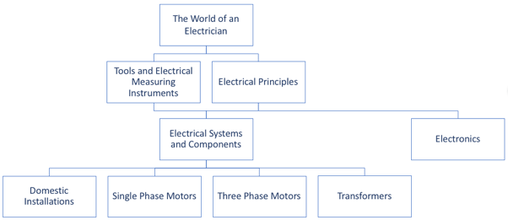
Figure 1: Relationships between Learning Pathways

In the sections below, details of these learning pathways are given especially as these relate to the summative practical assessments that learners will be required to complete in order to successfully exit the pathway (where relevant). In the Topic and Sequence sections, numbered references to the NOC: Electrician Open Learning Programme map have been given. See https://coggle.it/diagram/WuwXr7PNQyCVszID/t/occupational-certificate-electrician-v2 for the full map.

The World of an Electrician
Objectives
This pathway will provide a general overview of the
- Electrician trade including the characteristics and attributes necessary to be an electrician;
- Structure and importance of the Code of Practice;
- General safety requirements and procedures; and
- General literacies including drawings, units and IT

Specific entry requirements
- Grade 9 level Literacy and Numeracy
- Must be able bodied

Pathways assumed to have been completed
None

Topics and sequence
- 0.1 What is an Electrician?
- 0.2 The Code of Practice
- 0.3 General Basic Safety
- 0.4 Introduction to Drawings and Schematics
- 0.5 Working with Numerical Prefixes and Units
- 0.6 Basic Computer Literacy
- 0.7 Possible routes to the Trade Test

Tracking assessments
Formative assessments within learning activities and at end of each unit and topic.

Exit conditions (level 1)
Complete all topics and an online summative assessment.

Exit conditions (level 2)
None

Electrical Principles
Objectives
This pathway will provide learners with a theoretical and practical grounding in the basic principles of electricity (including Ohm’s Law, Kirchoff’s Laws) and Electromagnetism.

Specific entry requirements
- Grade 9 level Literacy and Numeracy

Pathways assumed to have been completed
- The World of an Electrician

Topics and sequence
- 1.1 Basic Atomic Theory
- 1.2 Electrical Circuits
- 1.3 Electromagnetism
- 1.4 Single Phase Generation and Distribution
- 1.5 Three Phase Generation and Distribution

Tracking assessments
Formative assessments within learning activities and at end of each unit and topic.

Exit conditions (level 1)
Complete all topics and an online summative assessment.

Exit conditions (level 2)
Complete a summative assessment under supervision at a testing centre.

Tools and Electrical Measuring Instruments
Objectives
This pathway will instruct learners in the types, uses and care of hand and power tools relevant to the Electrician trade (including gas cutting and arc welding tools), the specific relevant safety requirements for using these tools and instruct learners in the correct use and care of various electrical measuring instruments.

Entry requirements
- Grade 9 level Literacy and Numeracy
- Must be able bodied
- Access to necessary hand and power tools

Pathways assumed to have been completed
- The World of an Electrician

Topics and sequence
- 2.1 Basic Hand Tools
- 2.2 Basic Power Tools
- 2.3 Isolating and Lockout
- 2.4 Welding and Gas Cutting
- 2.5 Electrical Measuring Instruments

Tracking assessments
Formative assessments within learning activities and at end of each unit.

Exit conditions (level 1)
Complete all topics and an online summative assessment.

Exit conditions (level 2)
Compete the following practical assessment at a testing centre.

[Task 1] or [Task 2 AND Task 3]

Task 1: Manufacture a 90° Angle Bracket
From a provided piece of 300mm x 30mm x 5mm piece of iron or flat steel, manufacture a 90° angle bracket as shown in the diagram (or similar), to the following specifications:
- All tolerances and clearances within 0.5mm
- Side A must be square and flat
- Side B sawed at 90°
- Joint welded on insides only
- All burrs removed

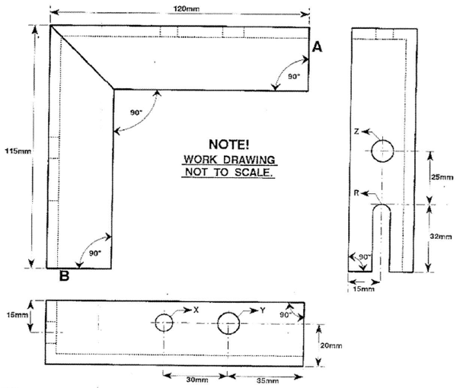

Task 2: Manufacture a Bus Bar
From a provided piece of 185mm x 40mm x 5mm flat steel, manufacture a bus bar as shown in the diagram (or similar) to the following specifications:
- All tolerances and clearances within 0.5mm
- All sides square to each other
- Narrow sides square to flat surface
- Top surface flat, shiny and scratch free
- All burrs removed
- Two short pieces interchangeable
- All holes drilled 8mm

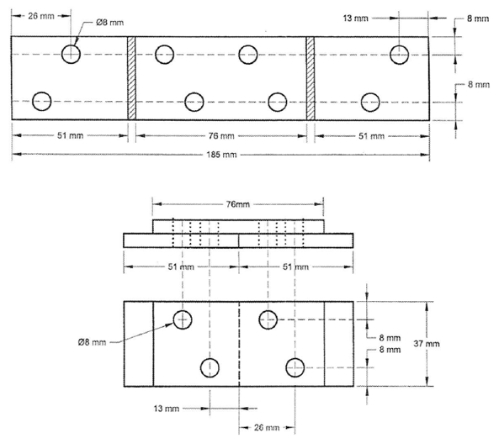

Task 3: Manufacture a Filing Block
From a provided piece of 80mm x 50mm x 6mm flat steel, manufacture the work piece as shown in the diagram (or similar) to the following specifications:
- All tolerances and clearances within 0.5mm
- Narrow sides square to each other and the flat surface
- Top surface flat, shiny and scratch free
- All burrs removed

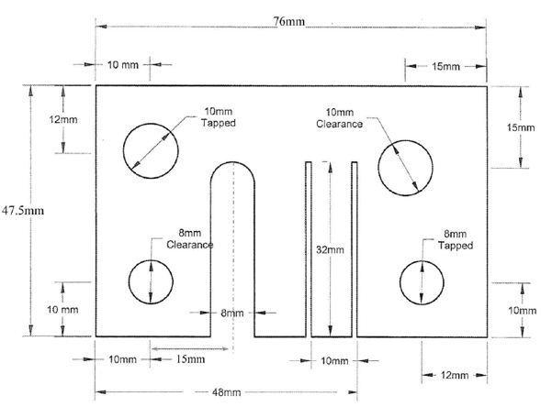

Exit conditions (level 3)
Complete and submit evidence of 4 weeks of workplace experience in a workshop working with various hand tools, power tools and electrical and mechanical measuring instruments.

The following kinds of activities should be completed:
- Observe and assist a qualified person in the selection, use, care and maintenance of hand tools, fixed and portable power tools and mechanical measuring instruments.
- On receiving relevant documentation and drawings, determine job requirements, complete a tool requisition/order and correctly and professionally complete the job according to workshop procedures and applicable safety requirements.

The following types of evidence will be accepted:
- Workplace log or other relevant documentation signed by a qualified person indicating number of hours spent and tasks performed (including proficiency and level of oversight provided).

Electrical Components and Systems
Objectives
This pathway will provide a detailed overview of the various real world electrical components and systems that working electricians will come across including the principles of earthing and bonding, metering systems and load balancing and PLCs.
Specific entry requirements
- Grade 9 level Literacy and Numeracy
- Must be able bodied

Pathways assumed to have been completed
- The World of an Electrician
- Electrical Principles
- Tools and Electrical Measuring Instruments

Topics and sequence
- 3.1 Cables and Conductors
- 3.2 Electrical Components
- 3.3 Low Voltage Circuit Protection
- 3.4 Earthing and Bonding
- 3.5 Metering Systems and Load Balancing
- 3.6 Industrial Lighting
- 3.7 Principles of PLCs

Tracking assessments
Formative assessments within learning activities and at end of each unit.

Exit conditions (level 1)
Complete all topics and an online summative assessment.

Exit conditions (level 2)
Compete the following practical assessment at a testing centre.

[Task 1 AND Task 2] AND [Task 4 OR Task 5] AND [Task 3 OR Task 7] AND [Task 6 AND Task 8 AND Task 9 and Task 10 AND Task 11]

Task 1: Complete a Cable Joint
Supplied with two lengths of 2.5mm² 2 – 4 core PVC armoured cable, a joining kit and necessary tools, join the two lengths of the cable according to the following specifications:
- All armouring strands joined to allow for full armour protection and earth continuity. Armour can be joined in groupings and joins can be staggered;
- The core of each cable a length of ±10mm;
- Supplied cast halves cut to the correct size to accommodate the cable;
- Conductors separately connected and crimped with supplied ferrules;
- Earthing strands re-joined in groups with supplied ferrules;
- Ends sealed with supplied self-seal tape;
- Joint filled with epoxy resin;

Task 2: Wire a Load Balanced Circuit Panel
From a 3-phase, 4-wire supply and earth, wire six 230V / 400V heater elements in order to ensure a combined and balanced load. The circuit must be controlled by a thermostat / time / pressure switch with a pilot light (230V / 400V, 2 W) to indicate that the elements are on. Other components supplied include:
- 1mm² conductor
- Triple pole circuit breaker (main);
- A contactor with 230V / 400V coil;
- A neutral bar;
- Two, 1 Amp circuit breakers or fuses; and
- An earth bar.

Task 3: Wire a Three-Phase Energy Meter Panel
From a 3-phase, 4-wire supply and earth, wire a supply authority meter to indicate the total energy consumed in accordance with all applicable safety measures and regulations. A consumer timer switch must also be wired into the circuit to allow it to be turned on and off and pre-set times. Other components supplied include:
- Supply authority neutral bar;
- Supply authority fuses or 3-Phase circuit breaker;
- Supply authority earth bar;
- Consumer's contactor;
- Consumer's switch fuse or 3-Phase circuit breaker;
- Consumer's neutral bar;
- Consumer's earth bar;
- Consumer's load connection terminals; and
- Consumer's 2 x 1 Amp fuses or circuit breaker.

Task 4: Wire a Three Heat Stove Switch
From a 1-phase supply and earth, wire a three-heat stove switch such that lamp 1 is in operation on the medium position. The lamp holders, three-heat stove switch and supply studs must be mounted on hardboard according to the diagram and in accordance with all applicable regulations. All wiring must be completed behind the panel in 1,5mm² conductor. Components supplied include:
- 1 x Piece of hardboard approximately 300mm x 200mm;
- 2 x Lamp holders;
- 2 x Lamps;
- 1 x Three heat stove switch;
- 1 x Switch knob;
- 6 x 6mm brass nuts and bolts;
- 24 x 6mm brass washers; and
- 4 x Spade connectors.

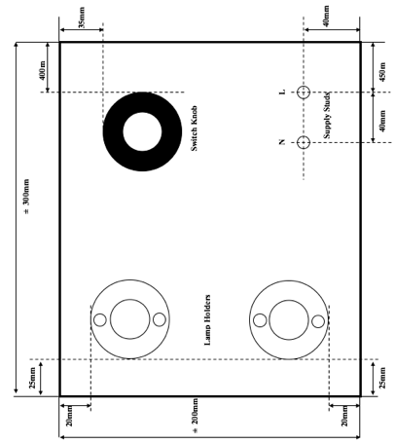

Task 5: Wire a Five Heat Stove Switch
From a 1-phase, supply and earth, wire a five-heat stove switch such that in position 3 lamp 1 only is one and in position 4 lamps 1 and 2 are in parallel. The lamp holders, five-heat stove switch and supply studs must be mounted on hardboard according to the diagram and in accordance with all applicable regulations. All wiring must be completed behind the panel in 1,5mm² conductor. Components supplied include:
- 1 x Piece of hardboard approximately 300mm x 200mm;
- 3 x Lamp holders;
- 3 x Lamps;
- 1 x Five heat stove switch;
- 1 x Switch knob;
- 8 x 6mm brass nuts and bolts;
- 32 x 6mm brass washers; and
- 5 x Spade connectors.

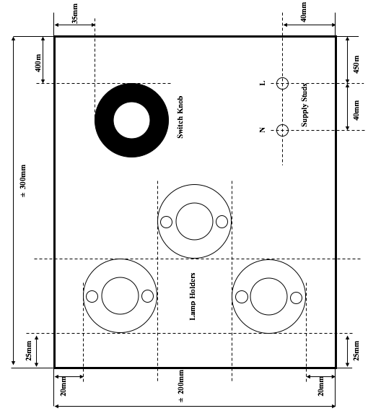

Task 6: Test a Low Tension Cable
With the aid of suitable testing instruments and according to all applicable safety procedures and regulations, test a length of low tension three-phase cable for faults (open circuit, short circuit or earth) and correctly record all results on an appropriate cable test form and report on the condition of the cable.

Task 7: Wire a Single-Phase Energy Meter
From a 1-phase supply and earth, wire a supply authority meter to indicate the total energy consumed in accordance with all applicable safety procedures and regulations. A consumer timer switch must also be wired into the circuit to allow it to be turned on and off and pre-set times. Other components supplied include:
- Supply authority neutral bar;
- Supply authority fuses or 1-Phase circuit breaker;
- Supply authority earth bar;
- Consumer's contactor;
- Consumer's switch fuse or 1-Phase circuit breaker;
- Consumer's neutral bar;
- Consumer's earth bar;
- Consumer's load connection terminals; and
- Consumer's 2 x 1 Amp fuses or circuit breaker.

Task 8: Wire a Mercury Vapour or High Pressure Sodium Lamp
From a 1-phase supply, wire a two-way switching circuit to control a mercury vapour or high-pressure sodium lamp. The circuit must be drawn, and all wiring must be done in accordance with the applicable safety procedures and regulations. Components supplied include:
- Circuit breaker;
- 2 x two-way switches;
- Mercury vapour or high-pressure sodium lamp;
- Lamp holder; and
- Conductors

Task 9: Wire a Three-Phase Energy Meter with Range Extension
Given a 3-phase, 4-wire supply and earth, wire a three-phase energy meter such that it is connected through a potential and current transformer to a given load. The full load current drawn by the load must not exceed the current and voltage rating indicated on the energy meter nameplate. All conductors and wiring must be in accordance with applicable safety procedures and regulations. Other components supplied include:
- Supply authority neutral bar;
- Supply authority fuses or 1-Phase circuit breaker;
- Supply authority earth bar;
- Consumer's contactor;
- Consumer's switch fuse or 1-Phase circuit breaker;
- Consumer's neutral bar;
- Consumer's earth bar;
- Consumer's load connection terminals; and
- Consumer's 2 x 1 Amp fuses or circuit breaker.

Task 10: Fault Finding
Given a faulty, live electrical circuit (3-phase or 1-phase), the accompanying circuit diagram and the necessary testing equipment, test the circuit to locate the fault and determine its probable cause. All steps in the faulty finding process should be documented and described and be taken in accordance with the applicable safety procedures and regulations.

Task 11: Wire a Timer Circuit Panel
From a 1-phase supply, wire a timer circuit panel controlling 3 lamps with 2 DPDT timers and a button such that on successive button presses lamps 1 then 2 then 3 then 1 light illuminate. Lamp 1 must be on before the button is pressed. The circuit must be drawn, and all wiring must be done in accordance with the applicable safety procedures and regulations. The Components supplied include:
- A one-amp circuit breaker;
- Neutral bar;
- Eleven-pin relay;
- Two DPDT timers;
- A push button; and
- Three lamps.

Domestics Installations
Objectives
This pathway will induct learners into the essential processes of designing, planning, conducting, testing, commissioning and fault finding various common domestic installations to ensure that these meet both client specifications and regulatory requirements.
Specific entry requirements
- Grade 9 level Literacy and Numeracy
- Must be able bodied

Pathways assumed to have been completed
- The World of an Electrician
- Electrical Principles
- Tools and Electrical Measuring Instruments
- Electrical Components and Systems

Topics and sequence
- 4.1 Wireways
- 4.2 Wiring of Installations

Tracking assessments
Formative assessments within learning activities and at end of each unit.

Exit conditions (level 1)
Complete all topics and an online summative assessment.

Exit conditions (level 2)
Compete the following practical assessment at a testing centre.

[Task 1] OR [Task 2 AND Task 3]

Task 1: Complete an Electrical Installation
Given a wooden board with two or three mounted obstructions, all required tools and materials, and a copy of the relevant regulations, complete the electrical installation according to the diagram (or similar) and in accordance with the applicable regulations. The following specifics apply:
- L1 (light), L2 (light), P1 (photocell), S1 (switch) and S2 (switch) tubed in 20mm PVC conduit;
- SI (40A stove isolator) tubed in 20mm steel conduit with one inspection bend (crutches to protrude no more than 10mm) and with 300mm installation wires for stove connection;
- S1 and S2 to independently control L1;
- L2 controlled by P1;
- Three core armoured cable fitted to bottom for supply with white core used as earth (earth tag on gland) and blue core as neutral;
- SO (16A socket outlet) wired using two pieces of surfix cable with joint(s) in trunking and crutches protruding between 5mm and 8mm;
- Distribution board completed, wired and bound with all circuit breakers labelled;
- No conduits or cables to cross;
- Component mounting within 5mm; and
- Pipes and cables straight and parallel (3mm per 100mm tolerance).

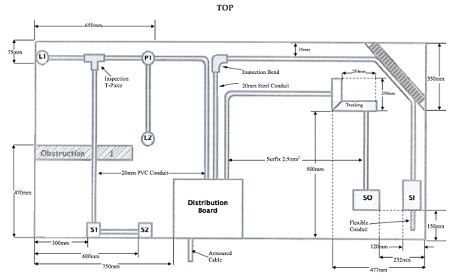

Task 2: Mount and Wire a Three Heat Stove Switch
Given a wooden board, all required tools and materials, and a copy of the relevant regulations, mount and wire a three-heat stove switch as per the diagram (or similar). The following specifics apply:
- Mount lampholders and three-heat stove switch and supply studs exactly as in the diagram;
- Wire the circuit such that 1 lamp on indicates medium position;
- All wiring with 1.5mm² cable behind board; and
- No marks on panel face.

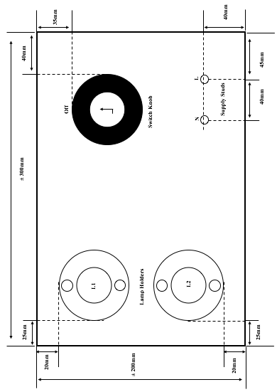

Task 3: Perform an Installation Inspection and Electrical Test
Given a single-phase domestic installation (stove isolator and/or geyser isolator and/or distribution board and/or socket outlet(s) and/or light fittings and/or switche(s) and a copy of the applicable regulations, perform an installation inspection and electrical tests. The inspection report should cover the following areas:
- Do all components (including cables and conductors) conform to the applicable standards?
- Have all components (including cables and conductors) been correctly and neatly installed?
- Are all components (including cables and conductors) suitably rated?
- Is there visible component damage?
- Are all circuit protection devices of the correct size and rating?
- Are all circuits electrically separated?
- Are all circuits, switches, fuses and breakers correctly labelled?
- Are all circuits correctly earthed and bonded?
- Are all aspects of the installation in accordance with all applicable regulations?

The electrical testing report should report on the following:
- Continuity and resistance of earth conductor including all bonding conductors;
- Continuity of ring circuit;
- Earth electrode resistance;
- Insulation resistance;
- Polarity;
- Earth fault loop impedance test;
- On load current readings; and
- Operation of earth leakage protection devices and circuit breakers.

Single-Phase Motors
Objectives
This pathway will give learners the knowledge and skills to design and build various single-phase AC motor starters common in industry and appliances as well as the knowledge and skills necessary to mechanically and electrically test and maintain single-phase motors and their starter circuits. This pathway also includes the knowledge and skills necessary to start, test and maintain DC motors.

Specific entry requirements
- Grade 9 level Literacy and Numeracy
- Must be able bodied

Pathways assumed to have been completed
- The World of an Electrician
- Electrical Principles
- Tools and Electrical Measuring Instruments
- Electrical Components and Systems

Components and sequence
- 5.1 How Single-Phase AC Motors Work
- 5.2 Wiring and Starting Single-Phase AC Motors
- 5.3 How DC Motors Work
- 5.4 Wiring ad Starting DC Motors

Tracking assessments
Formative assessments within learning activities and at end of each unit.

Exit conditions (level 1)
Complete all topics and an online summative assessment.

Exit conditions (level 2)
Compete the following practical assessment at a testing centre.

[Task 1 AND Task 2] OR [Task 2 and Task 3]

Task 1: Wire a Forward/Reverse Single-Phase Motor Starter
Give all necessary tools and materials (double pole isolator, 230V coil contactors, buttons, circuit breakers, ammeter, voltmeter), wire a single-phase capacitor start motor, using plug-in conductors and a supplied schematic so that:
- The motor can be operated in forward or reverse direction;
- When running in either direction the alternative direction start button is inoperative;
- A green light indicates motor is running in forward direction and an orange light indicates motor is running in reverse direction;
- The motor can be stopped using stop or emergency stop button;
- An ammeter indicates current drawn;
- A voltmeter indicates supply voltage; and
- The motor and circuit are protected from excessive supply voltage.

Task 2: Fault Find a Single-Phase Motor
Electrically inspect a single-phase motor (capacitor start, capacitor run, or capacitor start/capacitor run) wired with a single direction or forward/reverse starter, to determine if the motor and starter are fully serviceable and, if not, report on all existing faults and what must be done to remedy them.

Task 3: Wire a Single-Phase Capacitor Start Motor
Connect a plug and supply cord to a 220V single-phase motor with the following terminal block and installing the necessary bride pieces for the motor to run in one direction:
1. Running winding
2. Starting winding
3. Centrifugal switch
4. Capacitor

Three Phase Motors
Objectives
This pathway will give learners the knowledge and skills to design and build various three-phase AC asynchronous and synchronous motor starters common in industry as well as the knowledge and skills necessary to mechanically and electrically test and maintain three-phase motors and their starter circuits.

Specific entry requirements
- Grade 9 level Literacy and Numeracy

Pathways assumed to have been completed
- The World of an Electrician
- Electrical Principles
- Tools and Electrical Measuring Instruments
- Electrical Components and Systems

Components and sequence
- 6.1 How Asynchronous Motors Work
- 6.2 How Synchronous Motors Work
- 6.3 Wiring and Starting Three Phase Motors

Tracking assessments
Formative assessments within learning activities and at end of each unit.

Exit conditions (level 1)
Complete all topics and an online summative assessment.

Exit conditions (level 2)
Compete the following practical assessment at a testing centre.

[Task 1] OR [Task 2] OR [Task 3]

Task 1: Wire a Three-Phase Automatic Star-Delta Motor Starter
From a three-phase, four-wire supply, wire a 400V three-phase motor using plug in conductors and according to a supplied schematic so that:
- The motor starts in Star configuration and then automatically switches to Delta position;
- The motor can be stopped using a stop or emergency stop button
- An ammeter indicates current drawn;
- A voltmeter indicates line voltage;
- The motor and circuit are protected from excessive line voltage (with all calculations of overload settings done on a sheet of paper); and
- The control circuit can still be tested when the switch fuse isolator is in the closed position but the fuses have been removed.

Task 2: Wire a Three-Phase Sequence Motor Starter
From a three-phase, four-wire supply, wire two 400V three-phase motors, and given all necessary tools and materials (including triple pole circuit breaker, two 400V/230V coil contactors, buttons, two 1A fuses, two motor overcurrent protection units) using 1mm² conductors so that:
- Motor M.2 can only be started after motor M.1 is running;
- Both motors can be independently stopped by their respective stop buttons S.1 and S.2;
- When motor M.1 is stopped while motor M.2 is still running, motor M.1 cannot be restarted unless motor M.2 is stopped first;
- The emergency stop button must stop both motors immediately at all times; and

Also, the overload settings must be calculated, and all calculations provided on a sheet of paper.

Task 3: Fault Find a Three-Phase Motor
Electrically inspect a three-phase motor starter and motor(s) (forward/reverse or sequence starting or star-delta or auto transformer or two speed) to determine if the motor(s) and starter are fully serviceable and, if not, report on all existing faults and what must be done to remedy them.

Transformers
Objectives
This pathway will equip learners with the knowledge and skills to connect low voltage step-up and step-down transformers to achieve specific secondary line voltages. Learners will also gain the skills of using current and potential transformers to measure the current and voltage of transformers.

Specific entry requirements
- Grade 9 level Literacy and Numeracy

Pathways assumed to have been completed
- The World of an Electrician
- Electrical Principles
- Tools and Electrical Measuring Instruments
- Electrical Components and Systems

Topics and sequence
- 7.1 What Transformers Do and How They Work
- 7.2 Applications and calculations of Single Phase Transformers
- 7.3 Applications and calculations of Three Phase Transformers

Tracking assessments
Formative assessments within learning activities and at end of each unit.

Exit conditions (level 1)
Complete all topics and an online summative assessment.

Exit conditions (level 2)
Compete the following practical assessment at a testing centre.

[Task 1] AND [Task 2]

Task 1: Connect a Step-Down Transformer
Given three single-phase transformers with primary voltage tappings of 0V, -5%, 500V and 5% and a secondary voltage tapping at 110V, select the correct tappings to connect these transformers to a 500V three-phase supply to obtain a secondary three-phase line voltage of 60.4V or 181.45V or 190.5V or 200.5V. Use 1.5mm² PVC insulated conductors for all wiring and provide short supply, load and earth leads for further connections.

Task 2: Connect a Step-Up Transformer
Given three single-phase transformers with primary voltage of 110V and secondary tappings of 0V, -5%, 500V and 5%, select the correct tappings to connect these transformers to a 110V three-phase supply to obtain a secondary three-phase line voltage of 288.68V or 822.7V or 909.13V. Use 1.5mm² PVC insulated conductors for all wiring and provide short supply, load and earth leads for further connections.

Electronics
Objectives
This pathway will introduce learners to the key components (including diodes, resistors, capacitors and ICs) that make up electronic circuits, how these components function and the roles they play. Learners will gain the knowledge and skills to read schematics and construct circuits by creating various circuits using breadboards and veroboards. Learners will apply Ohm’s Law, Kirchoff’s Laws and RC calculations to design and calibrate various circuits.

Specific entry requirements
- Grade 9 level Literacy and Numeracy
- The Open Learning Electronics Kit

Pathways assumed to have been completed
- The World of an Electrician
- Electrical Principles
- Tools and Electrical Measuring Instruments
- Electrical Components and Systems

Topics and sequence
- 8.1 What is Electronics?
- 8.2 Circuit Basics
- 8.3 Resistors
- 8.4 Variable Resistors
- 8.5 Diodes
- 8.6 Transistors
- 8.7 Capacitors and Inductors
- 8.8 Circuit Design and Calculations
- 8.9 Integrated Circuits Chips
- 8.10 Electronics Projects

Tracking assessments
Formative assessments within learning activities and at end of each unit.

Exit conditions (level 1)
Complete all topics (including specified electronics projects) and an online summative assessment.

Exit conditions (level 2)
Compete the following practical assessment at a testing centre.

[Task 1] OR [Task 2] OR [Task 3]

Task 1: Design and build an AC to variable voltage DC power supply
Given the following schematic and all required tools and components, construct a variable voltage DC power supply circuit on a breadboard. Once built, demonstrate output voltages of 4V, 6V, 9V and 12V on an oscilloscope.
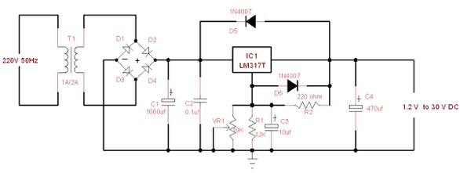
The following components are required:
- R1 – 12K Resistor (1/4W)
- R2 – 220 Ω Resistor (1/4W)
- VR1 - 10K Potentiometer
- C1 - 1000uF 50V Electrolytic Capacitor
- C2 - 0.1uF 63V Polyester Capacitor
- C3 - 10uF 35V Electrolytic Capacitor
- C4 - 470uF 35V Electrolytic Capacitor
- IC1 – LM317 IC
- D1, D2, D3, D4 – 50V 1A 1N4001 Diode
- D5, D6 – 1000V 1A 1N4007 Diode
- T1 - 21-24V 1A/2A Transformer

Task 2: Build an Audio Amplifier
Given the following schematic and all required tools and materials, construct an amplifier circuit on a breadboard. Test the circuit using an MP3 player/Signal generator and speaker.

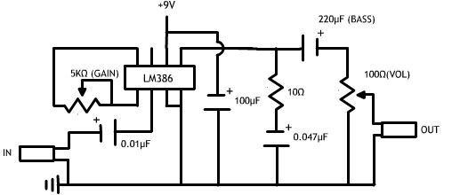

The following components are required:
- LM 386 semiconductor (IC)
- 100µF capacitor
- 220µF capacitor
- 10Ω resistor
- 5kΩ variable resistor
- 100Ω variable resistor
- 0.01µF capacitor
- 0.047µF capacitor
- Wires
- 9V Battery clip
- 9V Battery
- 3.5mm stereo jack (male)
- 3.5mm stereo jack (female)

Task 3: Build a Light Operated Switch
Given the following schematic and all required tools and materials, construct a light operated switch circuit on a breadboard. Test the circuit in a darkened room with a torch.

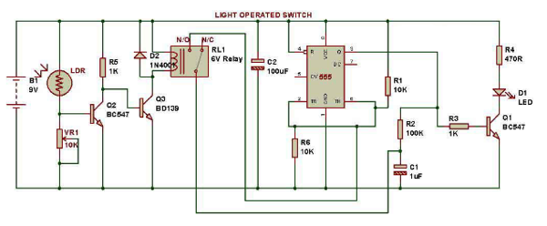

The following components are required:
- B1 - 9V battery
- LDR - Light Dependent Resistor
- VR1 - 10kΩ variable resistor
- R1 - 10kΩ resistor
- R2 - 100kΩ resistor
- R3 - 1kΩ resistor
- R4 - 470Ω resistor
- R5 - 1kΩ resistor
- R6 - 10kΩ resistor
- D1 – basic red 5mm LED
- D2 - 1N4001 diode
- RL1 - 6V relay
- C1 - 1µF capacitor
- C2 - 100µF capacitor
- Q1 – BC547 NPN transistor
- Q2 – BC547 NPN transistor
- Q3 – BD139 NPN transistor
- 555 Timer IC

