DEVELOPING CURRICULUM CONTENT AND OPEN LEARNING MATERIALS FOR THE OCCUPATIONAL CERTIFICATE FOR ELECTRICIANS

CURRICULUM AND PROGRAMME DESIGN CONTENT DOCUMENT

Introduction
This document describes the design of a new programme to support the Occupational Certificate: Electrician and based on the principles of open learning.

Background
The Department of Higher Education and Training (DHET) White Paper for Post-School Education and Training: Building an Expanded, Effective and Integrated Post-school System (White Paper), published in 2013, outlines the Department’s policy and strategic framework and therefore forms the essential foundation for this document and the programme design it describes.

The White Paper describes the following key challenges:
- A lack of venues for youth and adults seeking education and training;
- Inadequate quality of education provision;
- Weak and ineffectual institutions;
- A misalignment between education provision and the needs of the economy; and
- The intensification of structural challenges associated with unemployment and poverty.

Among the Department’s main policy objectives, therefore, are to create a single, coordinated system, to increase access to and improve the quality of a diverse range of education opportunities and to strengthen the links between the world of work and education, thereby helping to develop citizens who are prepared to be productive, creative and ethical members of society. In his preface, the former Minister of Higher Education stresses the need for the system to comprise a diverse range of institutions and opportunities of the highest possible quality and for multiple pathways to be available to students.

The White Paper states that the DHET’s highest priority is the strengthening and expansion of the Technical and Vocational Education and Training (TVET) system. From a total enrolment of 650,000 students in 2013, the DHET aims to increase enrolment to 2,5 million by 2030. In addition, the White Paper notes the need to improve throughput rates and to cater for a far wider variety of students with different needs, contexts and barriers.

A key objective in strengthening the TVET system is the formation and strengthening of partnerships between employers and colleges to increase and improve the exposure students get to the workplace as part of their studies as well as to ensure that programmes of study are fully responsive and relevant to the needs of industry.

A further objective is the rationalisation of TVET programmes and qualifications to make the system easy to administer and simpler to understand and access. This is also expected to result in better and more consistent quality assurance.

The White Paper speaks directly to the use of open learning (including distance education and e-learning) as an important strategic enabler in realising many of its objectives, including in the TVET system. It notes that open learning will be developed to compliment traditional campus-based provision and will consist of a “network of education providers supported by learning support centres and/or connectivity for students”. Together, these will enable the provision of a wide range of learning opportunities to potential students that are geographically and temporally more accessible, and that foster independent study and life-long learning. The White Paper goes on to say that such learning opportunities will be supported through the development and distribution of high quality national teaching and learning resources made available as Open Education Resources (OERs).

Qualification Details
This new programme is designed to support the delivery of the Occupational Certificate: Electrician: 671101000 (OC: Electrician) developed by the Quality Council for Trades and Occupations (QCTO) and registered with the South African Qualifications Authority (SAQA) as an NQF Level 4 qualification. The qualification carries 360 credits and replaces a number of older qualifications. The OC: Electrician, therefore, represents a consolidation of various sector specific qualifications into a single qualification for all electricians.

Programme Curriculum
The OC: Electrician Curriculum Document, developed in consultation with the various industrial sectors in which Electricians work, represents the full curriculum on which the programme will be based. This Curriculum Document outlines the core knowledge, practical skills and work experience required by trainees in order to become qualified electricians. It also enumerates assessment criteria for each identified portion of knowledge, skill and work experience as well as the necessary physical, human resource, and legal requirements for formal summative assessment.

The curriculum consists of the following knowledge, skill and work modules:

Knowledge Modules (KM) and Knowledge Topics (KT)
- KM-01: Health, Safety, Quality and Legislation
  - KM-01-KT01: Safety, health, environment, risk and quality principles in the workplace
- KM-02: Tools, Equipment and Materials
  - KM-02-KT01: Hand tools and power tools
  - KM-02-KT02: Measuring and testing instruments
- KM-03: Electricity and Electronics
  - KM-03-KT01: Fundamentals of electricity
  - KM-03-KT02: Electronics
  - KM-03-KT03: Earthing and bonding
- KM-04: Industry Context
  - KM-04-KT01: Introduction to the world of work and the electrical trade
- KM-05: Wire ways and wiring
  - KM-05-KT01: Wire ways
  - KM-05-KT02: Wiring of installations
  - KM-05-KT03: Earthing and bonding
- KM-06: Rotating electrical machinery
  - KM-06-KT01: Rotating electrical machinery - AC motors
  - KM-06-KT02: Rotating Electrical Machinery - DC motors
  - KM-06-KT03: Rotating electrical machinery - Alternators and Generators
- KM-07: Electrical supply systems and components
  - KM-07-KT01: Concepts, theories and principles of supply Systems
  - KM-07-KT02: Batteries
  - KM-07-KT03: Transformers
  - KM-07-KT04: Types of cables and applications
  - KM-07-KT05: Switchgear and control gear
  - KM-07-KT06: Lighting systems
- KM-08: Low Voltage protection
  - KM-08-KT01: Low voltage protection
- KM-9: Fault Finding
  - KM-09-KT01: Fault finding

Practical Modules (PM) and Practical Skills (PS)
- PM-01, Use hand, power and measuring tools
  - PM-01-PS01: Select, use and care of engineering hand tools
  - PM-01-PS02: Select, use and care for power tools
  - PM-01-PS03: Select, use and care for electrical measuring instruments
  - PM-01-PS04: Perform soldering activities
  - PM-01-PS05: Carry out basic electric arc welding in an electrical environment
  - PM-01-PS06: Carry out basic gas cutting in an electrical environment
- PM-02, Plan worksite set up for installing, wiring and connecting electrical equipment and control systems
  - PM-02-PS01: Undertake risk assessment in accordance with all statutory requirements
  - PM-02-PS02: Read and interpret electrical drawings
  - PM-02-PS03: Plan the worksite set-up
- PM-03, Prepare worksite set up for installing, wiring and connecting electrical equipment and control systems
  - PM-03-PS01: Procure resources
  - PM-03-PS02: Prepare and transport resources
  - PM-03-PS03: Prepare work site, equipment, tools, consumables and materials
- PM-04, Install wire-ways
  - PM-04-PS01: Confirm the selection and installation method of the selected wire ways
  - PM-04-PS02: Use installation tools and equipment
  - PM-04-PS03: Design and install wire ways
- PM-05, Install, wire and connect electrical equipment and control systems
  - PM-05-PS01: Identify hazards within the installation
  - PM-05-PS02: Confirm the selection and installation method of the electrical equipment and control systems
  - PM-05-PS03: Use installation tools and personal protective equipment
  - PM-05-PS04: Install equipment and control systems
  - PM-05-PS05: Wire electrical equipment and control systems
  - PM-05-PS06: Terminate and connect cables and conductors
- PM-06, Conduct pre-commission inspection (power off) and test new and existing installations
  - PM-06-PS01: Inspect electrical equipment, control systems and installations under power off conditions
  - PM-06-PS02: Test electrical equipment, control systems and installations under power off conditions
- PM-07, Carry out commissioning tests
  - PM-07-PS01: Carry out commissioning tests (with power on) of electrical installations and control systems
  - PM-07-PS02: Rectify defects found on electrical installations and control systems
  - PM-07-PS03: Report product deficiencies and rectify workmanship
- PM-08, Fault find and repair electrical control systems and electrical installations
  - PM-08-PS01: Obtain work instructions and gather drawings and documentation
  - PM-08-PS02: Select tools and testing instruments
  - PM-08-PS03: Carry out fault finding
  - PM-08-PS04: Rectify faults where applicable
  - PM-08-PS05: Record findings and provide feedback

Work Modules (WM) and Work Experience (WE)
- WM-01, Planning and preparation process for the wiring, connection, testing, inspecting, commissioning and maintaining of electrical installations and control systems
  - WM-01-WE01: Observe and assist a qualified person in the planning and preparation process for electrical installations and control systems
  - WM-01-WE02: Plan and prepare for electrical installations and control systems under the direct supervision of a qualified person
  - WM-01-WE03: Undertake all activities without assistance, but under supervision, to plan and prepare for electrical installations
- WM-02, Processes of installing, wiring and connecting of electrical equipment and control systems
  - WM-02-WE01: Observe and assist a qualified electrician in the processes of installation, wiring and connection of electrical equipment and control systems
  - WM-02-WE02: Install, wire and connect electrical equipment and control systems under the direct supervision of a qualified electrician
  - WM-02-WE03: Undertake all activities without assistance, but under supervision, to install, wire and connect electrical equipment and control systems
- WM-03, Processes of testing and inspecting electrical installations and control systems
  - WM-03-WE01: Observe and assist a qualified person in the processes of testing and inspecting of electrical equipment, control systems and installations
  - WM-03-WE02: Processes of testing and inspecting of electrical equipment, control systems and installations under the direct supervision of a qualified person
  - WM-03-WE03: Undertake all activities without assistance, but under supervision, in the processes of testing and inspecting of electrical equipment, control systems and installations
- WM-04, Processes of commissioning electrical installations and control systems
  - WM-04-WE01: Observe and assist a qualified person in the processes of commissioning electrical installations and control systems
  - WM-04-WE02: Processes of commissioning electrical installations and control systems under the direct supervision of a qualified person
  - WM-04-WE03: Undertake all activities without assistance, but under supervision, to commission electrical installations and control systems
- WM-05, Maintenance processes for equipment, control systems and electrical installations
  - WM-05-WE01: Observe and assist a qualified person in the maintenance processes for equipment, control systems and electrical installations
  - WM-05-WE02: Maintenance processes for equipment, control systems and electrical installations under the direct supervision of a qualified person
  - WM-05-WE03: Undertake all activities without assistance, but under supervision, in maintenance processes for equipment, control systems and electrical installations

It must be noted that the structure of the curriculum cannot be used as the structure of the programme. As the curriculum was developed to address the training needs of electricians in multiple contexts, many of the modules are not context specific and the curriculum is, therefore, lacking certain contextual details.

An example of this can be found in PM-03, Prepare worksite set up for installing, wiring and connecting electrical equipment and control systems. The exact requirements of what a student must know differ for different work contexts and work-based tasks. The concept of “control systems” also lacks specificity as such systems could refer to those controlling domestic light installations or industrial A/C motors – again context dependent.

Further, the eight Practical Modules are designed and organised to describe the basic electrical workflow, from site preparation to installation, to testing. However, the specifics of each step differ depending on the context and the task.

For this reason, it is necessary to orientate and structure the programme around specific work-based tasks rather than using any structure inherent in the curriculum. In this way curriculum modules will need to be developed and then referenced in multiple places within the programme. See the section on Programme Structure for more details.

International Comparability
In awarding the qualification, SAQA performed a benchmarking exercise with four other countries (Australia, New Zealand, United Kingdom, and Canada) to ensure international comparability. The review found that the OC: Electrician is “generally comparable” to what is found in the other countries.

As the programme is based exclusively on the OC: Electrician, it can be assumed to be internationally comparable with similar programmes.

Programme Rational
The primary rational for the programme is to expand access to high quality instruction and resources for students, especially non-contracted students following the Assessed Required Prior Learning ARPL route, who wish to become qualified electricians, by adequately preparing them for the stipulated External Integrated Summative Assessment (EISA) and to do so in ways that simultaneously make such access as affordable as possible.

A secondary rational is to offer students the opportunity to gain only a specified sub-set of knowledge and skills in order to be more economically active and productive. While no formal qualification will accrue, the economic benefits to the individual and his/her community are still likely to be significant.

As the qualification being addressed is occupational, and, therefore, highly practically orientated, the programme will integrate with other parts of the system which can provide students with access to the practical skill instruction and work based experience required by the qualification.

In addition, while the programme will offer several opportunities for informal formative assessment, integration with other parts of the system will be required for all formal summative assessments, especially with regards to practical skills.

Key programme outcomes
The programme exit level outcomes reflect the exit level outcomes of the OC: Electrician qualification, namely:
- The ability to plan and prepare work site, equipment, tools, consumables and materials for electrical activities and operations;
- The ability to install, wire and connect electrical equipment and control systems;
- The ability to test and inspect electrical equipment, control systems and installations;
- The ability to commission control systems and installations; and
- The ability to maintain and repair electrical equipment, control systems and installations.

In addition, even though there are no recognised part qualifications, the programme will allow students to access portions of the programme of their choosing and which represent a sub-set of skills and knowledge that these students require in order to be more economically active and productive.

Programme Design Framework
A specific Programme Design Framework (see figure 1) is being used to guide the design and development of the programme. This framework draws on work done by the Open University.

The framework requires the definition of the following three key programme attributes:
- People and context – Who is the programme being designed for and what is their life and learning context?
- Purpose and objectives – Why is the programme being developed? What does the programme need to achieve? What does success look like?
- Principles and pedagogies – What are the foundational educational principles on which the programme will be built? What kinds of teaching and learning practices will be used?

At the lowest level, the framework requires the design and development of sequenced sets of learning activities, each one with defined learning outcomes, learning tasks and assessments. These learning activities are, in turn, supported by specifically designed teaching and learning resources.

Between the macro programme attributes and the micro learning activities lies the programme structure of course, modules, topics and units.

Underpinning all levels of the programme are a detailed set of programme features that help to translate the programme attributes into more practical supports for the learning activities. These include:
- Guidance and support – How will students be guided through the programme and what kinds of supports will be offered along the way?
- Communication and collaboration – How will students be encouraged and empowered to communicate and collaborate with other students and with instructors? What role will group work have in the programme?
- Content and experience – What kinds of learning materials will be made available and how will these be made available? What specific learning experiences will be offered to students?
- Reflection and demonstration – How will students be encouraged to reflect on what they are learning and how they can apply it? What kinds of opportunities will students be given to demonstrate what they have learnt?

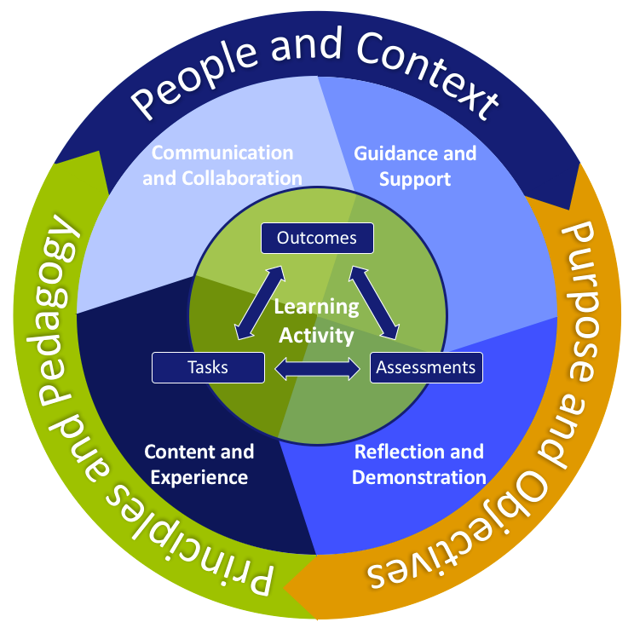
Figure 1: Programme Design Framework

It is important to note that the design framework works as an integrated whole. While one may start by defining the programme attributes, these are not immutable and are open to being modified during the course of the programme development as more details related to learning activities and programme features are defined.

Programme Attributes
The following programme attributes have been defined for the programme.

People and Context:
In terms of the people and their context for which this programme will be developed, the following summarises the key facets that need to guide the programme’s design and implementation.

- Many students experience significant time constraints and competing priorities. For example, some students are the heads of their households. Others may be in full- or part-time employment in order to support them and their families and, as such, full-time formal study is not possible.
- Many students live far from training providers and transport to and from providers is costly, lengthy and erratic. These students require learning opportunities that are easier to access where they are.
- There are significant levels of poverty amongst many students. Access to learning resources and reliable and affordable transport to and from college are real challenges. These students require the cost of study to be lowered as far as possible.
- While some students can be considered adult learners, the majority of students are young (below the age of 22) and do not have much learning experience outside the context of formal schooling.
- Many students lack some of the foundational literacy, communication and numeracy/mathematical skills one would expect after exiting 9 or 12 years of formal schooling.
- For the vast majority of students, English is not a home language.
- Currently there is some abuse of the stipend system by contracted students whereby they delay their exit from a programme as long as possible by purposely failing the trade test in order to retain the stipend.
- Many students enrol in programmes in order to secure the stipend which may be their family’s only source of income. For this reason, they are motivated purely by economics rather than by any enduring desire to be an electrician.
- Most students have their own mobile devices (most of these are smart rather than feature phones) and they use them constantly for a variety of means including communication, information and media access and media production and sharing.
- There is an observed tendency among students to do the bare minimum. Many students lack a work ethic or demonstrate any pride in what they do.
- Those students who purposefully choose to become electricians tend to be highly practically orientated.
- While many students are “money orientated” they also tend to be aspirational.

This programme will be designed with three basic types of students in mind.

Firstly, students who have acquired a significant amount of knowledge of the electrician trade through past work experiences but do not have any formal qualification are the primary target group of this programme. Such students are catered for currently through an ARPL process. Part of this process is the requirement to present a portfolio of evidence of skill and knowledge. In areas where the student is deemed to not yet be sufficiently prepared for the trade test, they are required to acquire additional knowledge and experience. This programme will enable such students to review knowledge and skills in which they are not yet competent and develop additional elements for their portfolio of evidence.

Secondly, traditional students who attend TVET colleges and enter apprenticeships with workplaces will have access to the programme either as a supplementary source of instruction and practice or as a partial replacement of campus based instruction, particularly for the knowledge components of the curriculum. In addition, they may be in a position to only attend the campus on specific days for specific practical sessions thereby alleviating some of the costs associated with transport. It will also enable more students, currently unable to study full-time, to access this learning opportunity in that it will provide a far greater degree of flexibility.

This programme will also allow TVET colleges to increase their enrolment and better utilise their workshop facilitates by allowing students to do as much learning as possible off campus.

Thirdly, the programme will enable students to acquire very specific sets of skills without the need to enrol for the full qualification or go through the ARPL process. While there are no registered part qualifications, economic realities may dictate that a student simply needs to acquire the skills, for example, to install and maintain pool pumps. In this instance, the student need only work through a single programme module dedicated to A/C machines in order to fulfil one or other job requirements or, indeed, to be able to access employment opportunities, including self-employment.

Purpose and Objectives:
The following objectives have been defined for the programme.
- The overall objective of the programme is to create wider access for more students to high quality practical instruction in electrician skills at an affordable price.
- The programme will address the needs of contracted students (apprentices), non-contracted students (those whose route to becoming qualified electricians lies in ARPL) and part-time students (those seeking acquisition of specific skills rather than a qualification). Emphasis will be placed on ARPL students.
- The programme will provide high-quality, standardised, free and open teaching and learning materials to the system to be used and/or adapted by public and private service providers alike. The nature and quality of the teaching and learning materials will be such that they will support the professional development of instructors.
- The programme will aim to foster independence, diligence and pride in students as well as an entrepreneurial mindset for the creation of new employment opportunities.

Principles and Pedagogies:
In order to meet is objectives and the needs of the target students, the following key principles and pedagogies have been identified.
- The programme must effectively and fully integrate the knowledge, practical and work experience components of the OC: Electrician curriculum. Working effectively as an electrician requires good theoretical knowledge of electricity, excellent practical skills in working with electricity and practiced application of these skills in real-world work contexts.
- The programme must be focus on developing students’ practical skills and their ability to apply theory effectively by employing active learning pedagogies and task based learning activities. Students must constantly be required to reflect on and apply new knowledge and skills in a variety of contexts and must be constantly required to demonstrate what they know through a variety of means including online tests, practical tasks and portfolio generating activities.
- The programme must develop student’s problem-solving abilities by employing problem-based instructional approaches in real-world and authentic contexts.
- The programme must engage students through the use of diverse, accessible, interesting, attractive and stimulating media and other resources. In particular, the amount of passive reading should be kept to a minimum.
- The programme must encourage students to be independent not only in time and space but also in terms of motivation. Hence, the programme will offer as much student choice as possible as well as opportunities to voluntarily interact with other students for mutual benefit.
- The programme must assess student’s progress regularly. Such formative assessment should be used to direct students to appropriate learning pathways.
- The programme must be modular and offer students short, manageable learning opportunities with clear feedback and progress indicators. This is to promote and enhance flexibility but also to prevent students from becoming overwhelmed and demotivated.
- All programme materials and resources must use simple and accessible English that is clear and unambiguous.
- The programme must offer multiple avenues of practical support and guidance to students in the form of computer-based support, access to online and offline mentor and facilitator support and access to online student based support.
- The programme should aim to develop pride in work and a good work ethic among students by requiring students to share their work and experiences with students and other authentic audiences and to give and receive feedback on it.
- The programme must address across all work contexts relevant to the electrician trade.
- The programme must employ social learning methodologies whenever practical and encourage, empower and support active and collaborative learning communities.

Programme Features

Guidance and Support
In order for the student to successfully complete their courses of study, the programme will ensure that there are adequate and varied forms of guidance and support provided to the student. Here are some of the avenues envisioned:
- Online forums where students can interact with other students and mentors or instructors from TVET colleges or other registered service provider institutions;
- Online facilitation of certain modules deemed as being especially difficult or technically challenging;
- Contact sessions or private electronic communications with TVET college instructors as mentors;
- Contact sessions or private electronic communications with workplace mentors;
- WhatsApp groups whereby a mentor or master electrician in the workplace is available to answer questions that arise when the students are doing practical activities;
- Guidance manuals and other online and offline materials for students;
- Online documentation highlighting important information on how to book trade tests, summative practical tasks etc.;
- Guidelines for mentors (colleges and workplace) on how to effectively mentor students;
- Short “How to” videos to instruct students on how to make the best use of the learning platforms and materials; and
- A dedicated person or team of people to address systems or access challenges (their contact information would be shared on the LMS).

Communication and Collaboration
At Workshop 1 the Subject Matter Experts mentioned that the students (especially students in the under 25 years of age category) are already establishing ways in which to communicate and collaborate with their peers. An example of this is students messaging each other in order to obtain notes from a lecture they were unable to attend. Here are some additional ways in which communication and collaboration can be encouraged:
- Peer evaluations of work submitted online (for example, students can be asked to determine whether their fellow learner has wired a circuit board correctly);
- A Frequently Asked Questions (FAQ) page on the LMS, highlighting information frequently searched for or requested by students; and
- The establishment of WhatsApp groups or discussion forums where students can connect with others either in the same geographic location or alternatively in their same area of specialisation.

Content and Experience
Providing high quality and engaging content and experiences will comprise the bulk of the programme. Here are some examples of the types of content and experiences that the students will have access to.
- Online information and demonstration videos;
- Relevant readings;
- Simulation experiences whereby students have opportunities to practise their skills in a simulated environment before attempting it in a test or the workplace;
- Case-studies highlighting and explaining the demands of the world of work; and
- Real-world educational experiences where the learners are required to go into the workplace or a normal day-to-day environment to complete certain tasks before submitting evidence of completion in the form of an uploaded video, photograph or self-reflection.

Reflection and Demonstration
Students will have varied opportunities to reflect upon and test their acquired knowledge and skills. Here are some examples.

- Online “Test yourself” formative assessments after a section of work. These would be structured in such a way that immediate feedback is provided to the student;
- Summative assessments at training centres for the demonstration of practical skills;
- Portfolio of evidence tasks requiring students to demonstrate and document their competence in specific tasks. (the portfolio of evidence can then be presented to the training centre as additional evidence of learning(; and
- Practical demonstrations both in the workplace or training centre environment, guided by experienced facilitators.

Programme Structure
The programme will initially comprise eight modules, each divided into several topics. Module 1 is a cross-cutting module that provides fundamental practical skills essential for each of the other modules.

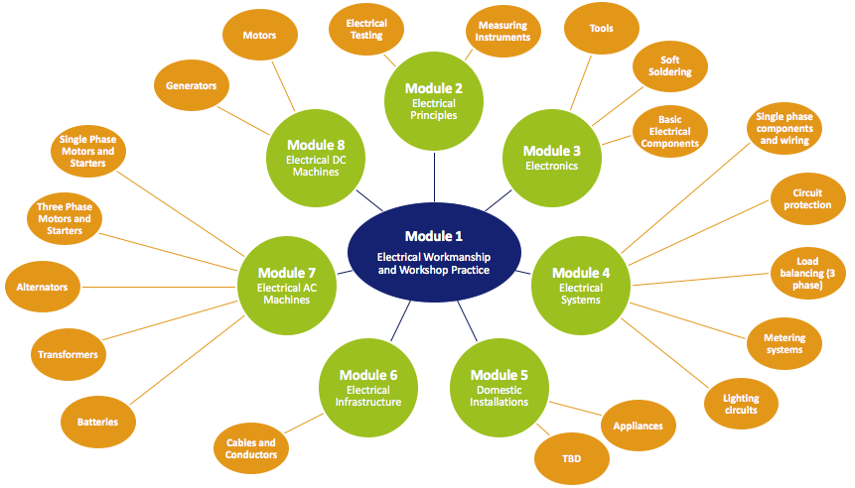
Figure 2: Programme Modules

The Electrical Workmanship and Workshop Practice module consists of the following topics:
  - First Aid
  - Occupational Safety
  - Hand tools
  - Power tools
  - Gas cutting
  - Arc welding
  - Workshop equipment
  - Measuring tools

Supporting each of these modules and topics will be one to several learning pathways made up of a sequence of learning activities clustered into logical learning units. Each learning activity will deal with a specific knowledge and/or practical and/or work experience component as defined in the curriculum. Each learning activity will consist of:
- Specific learning outcomes;
- One or more learning tasks; and
- Assessment criteria and related instruments.

Due to the nature of the curriculum (as described in the Programme Curriculum section) many, if not most, learning units (or even individual learning activities) will be applicable to multiple modules or topics. For example, a learning unit dealing with basic atomic theory, will be relevant to Module 2: Electrical Principles, Module 3: Electronics and Module 4: Electrical Systems.

Rather than develop the same set of learning activities multiple times, this learning unit can simply be referenced by all three modules. Completion of this learning unit by the student is only required once. If, for example, this learning unit was completed as part of Module 2, the student would not be required to redo it in Module 3 or 4 (unless they chose to for review or revision purposes).

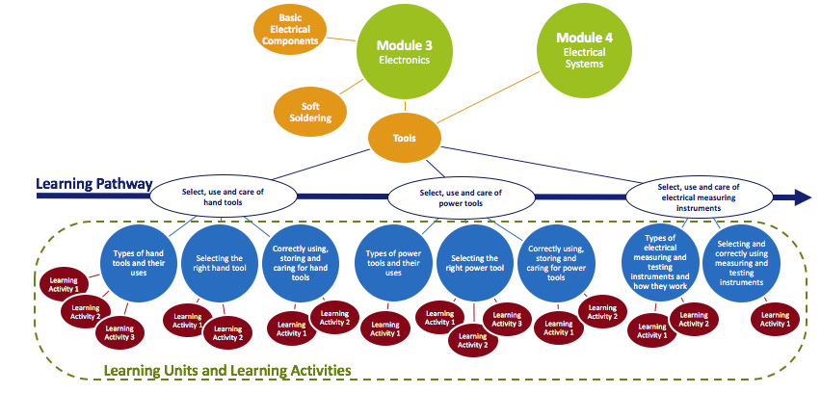
Figure 3: Programme Structure

Where there are slight differences in how the information within a learning unit relates to different modules, only those portions of the learning unit that are different need be developed for application to other modules.

In this way, the underlying structure of the programme can be described as being similar to Lego. Individual bricks (individual learning activities and/or learning units) can be assembled and reassembled into multiple configurations. While the programme design currently describes 8 modules, new modules can be designed and configured in future. For example, a module dealing explicitly with the installation, testing and maintenance of pool pumps can be created using the existing library of “blocks”.

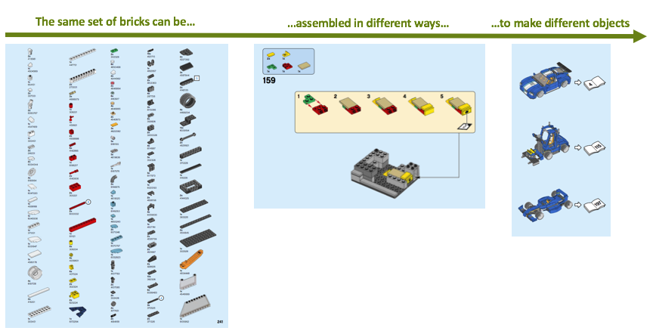
Figure 4: Programme modular approach

In this way:
- The learning activities, learning units and supporting teaching and learning resources can be reused for different purposes with no or minimal adaptation;
- While the teaching and learning resources can be used by instructors in isolation, one always has the option of using them in conjunction with their learning activities and/or learning units reducing the need for and, cost and time of new instructional design and simultaneously providing high quality ready-made instructional design options;
- The model exemplifies and demonstrates to public and private training providers how they can reassemble the programme’s constituent parts to suit their own unique training needs; and
- The programme design remains flexible and able to respond to new, unforeseen training requirements in future.

Programme Delivery
The programme will be developed according to the principles of open learning and in particular increased access to high quality instruction at an affordable cost. While the programme will make extensive use of e-learning and online learning modalities, the programme is not an online programme.

Many of the knowledge components can be delivered online and some of the application of knowledge and skill can be done online or in the student’s own environment. However, the highly specialised and practical nature of the subject matter dictates that students engage in various practical tasks to be completed and assessed at TVET colleges, other registered institutions with the requisite workshops and equipment or appropriate workplaces. Thus, this programme will need to be integrated into a wider system of support institutions.

Not only is this necessary from the perspective of the practical skills and work experience involved but also so that students are able to access additional support and guidance from a variety of expert sources both online and face-to-face.

Even though the programme is not an online programme and will involve extensive practical work on the part of students, it is envisaged that the programme will be delivered and mediated to students through a Learning Management System (LMS). Where appropriate, the LMS will deliver learning activities and supporting resources to students online. However, in many other cases, the LMS will direct students to offline facilitates or institutions in order to gain the practical and work experience required.

It is not clear at this point what LMS will be used to deliver the programme. Once a first set of learning units, learning activities and supporting teaching and learning resources have been designed, a list of technical requirements will be drawn up to guide the selection of a suitable LMS. However, at this point the following requirements are known. The LMS will need to:
- Support the presentation of a variety of media types including audio-visual, image, text and interactive;
- Support the presentation of learning activities and resources according to defined learning pathways which may include specific dependencies or branches;
- Track student progress through learning pathways and award acknowledgement of completion at defined points (badges);
- Support the presentation and automatic marking of a range of online assessment item types including, multiple choice, cloze, dropdown, image hotspot, drag and drop, mathematical, and circuit diagram questions;
- Support the ability for students to upload electronic portfolio of evidence items;
- Support online synchronous and asynchronous chat and discussion fora;
- Support the ability for authorised assessors to capture student assessment results;
- Support smart phone mobile access and employ mobile first design principles; and
- Support the ability for students to work offline and to take materials and resources offline for later data synchronisation with the cloud (this will more than likely require a mobile application).

The following student workflow is envisaged.
- A student will visit the programme website and self-register.
- The student will complete a short assessment that includes aptitude and interest questions.
- The student will be asked what learning pathway they would like to access.
- For the ARPL pathway, the student will be directed to select the modules that would like to access.
- For the contracted student pathway, the student will be directed to module 1.
- For the part-time pathway, the student will be asked what they would like to do. The programme (and any other modules designed in future) will be presented to student as a set of “I want to learn about…” statements. Note, the student may select multiple options.
- After making their selection, the student will be directed to enrol in the chosen pathway.
- After enrolment, the student will be directed to the module(s) of their choice to begin their first learning pathway.
- The student will work their way through the learning activities in the pathway in their prescribed order. Some of these learning activities will include formative self-assessments (either online assessments, practical tasks or portfolio item generating tasks).
- At some point, the student will be required to complete a summative practical assessment task at an TVET college or other registered testing institution. The student may elect to do this assessment task before continuing or they may continue with another learning pathway and so accumulate several practical summative assessments tasks.
- At some point, the student will be required to contact a TVET college or other registered testing institution and book a time to be assessed on any practical assessment tasks they have accumulated.
- Before the student arrives for their assessment, they will be required to compile any portfolio of evidence items.
- The student will arrive and complete their summative practical assessment task(s). The instructor may use programme provided materials with which to conduct and evaluate the assessment.
- On completion, the assessor will provide the student an assessment report which the student will upload to their programme profile. Uploading of this assessment report will constitute completion of the summative practical assessment task.
- The student will thus complete all learning pathways associated with all requisite modules.
- Should the student elect to complete the EISA, they will follow the standard process but supply their portfolio of evidence as managed by the programme to the assessor.

Addendum A: List of old qualifications replaced by the Occupational Certificate: Electrician (671101000)

- 63889, "Further Education and Training Certificate: Electrical Engineering", Level 4, 130 Credits
- 72052, "Further Education and Training Certificate: Electrical Engineering", Level 4, 130 Credits
- 72072, "Further Education and Training Certificate: Electrical Engineering: Chemical", Level 4, 130 Credits
- 72070, "Further Education and Training Certificate: Electrical Engineering: Electrical Construction", Level 4, 130 Credits
- 23625, "National Certificate: Electrical", Level 4, 301 Credits
- 20420, "National Certificate: Electrical Engineering", Level 4,120 Credits
- 73313, "National Certificate: Electrical Engineering", Level 2, 140 Credits
- 20418, "National Certificate: Electrical Engineering", Level 2, 120 Credits
- 48474, "National Certificate: Electrical Engineering", Level 4, 134 Credits
- 48473, "National Certificate: Electrical Engineering", Level 2, 143 Credits
- 63790, "National Certificate: Electrical Engineering", Level 3, 133 Credits
- 48475, "National Certificate: Electrical Engineering", Level 3, 127 Credits
- 20419, "National Certificate: Electrical Engineering", Level 3, 120 Credits
- 72051, "National Certificate: Electrical Engineering", Level 3, 133 Credits
- 63789, "National Certificate: Electrical Engineering", Level 2, 140 Credits
- 72074, "National Certificate: Electrical Engineering: Chemical", Level 3, 133 Credits
- 67431, "National Certificate: Electrical Engineering: Chemical", Level 2, 140Credits
- 72073, "National Certificate: Electrical Engineering: Electrical Construction", Level 3, 133 Credits
- 67430, "National Certificate: Electrical Engineering: Electrical Construction", Level 2, 140 Credits
- 72071, "National Certificate: Electrical Engineering: Mining", Level 3, 133 Credits
- 67429, "National Certificate: Electrical Engineering: Mining and Minerals", Level 2, 140 Credits
- 72080, "National Certificate: Electrical Engineering: Transport", Level 3, 133 Credits
- 67434, "National Certificate: Electrical Engineering: Transport", Level 2, 140 Credits

http://www.dhet.gov.za/SiteAssets/Latest%20News/White%20paper%20for%20post-school%20education%20and%20training.pdf (accessed 22 November 2017).
The White Paper on Education and Training (1995) offered the following definition: Open learning is an approach which combines the principles of learner centeredness, lifelong learning, flexibility of learning provision, the removal of barriers to access learning, the recognition for credit of prior learning experience, the provision of learner support, the construction of learning programmes in the expectation that learner can succeed, and the maintenance of rigorous quality assurance over the design of learning materials and support systems.
http://www.dhet.gov.za/SiteAssets/Latest%20News/White%20paper%20for%20post-school%20education%20and%20training.pdf (accessed 22 November 2017).
http://ol4nocelectrician.weebly.com/uploads/1/0/5/5/105592609/south_african_qualifications_authority_registered_qualification.pdf (accessed 22 November 2017).
See Addendum A for a list of the qualifications being replaced.
http://ol4nocelectrician.weebly.com/uploads/1/0/5/5/105592609/occupational_certificate_qualification_electrician_curriculum_document.pdf (accessed 23 November 2017).

