DEVELOPING CURRICULUM CONTENT AND OPEN LEARNING MATERIALS FOR THE OCCUPATIONAL CERTIFICATE FOR ELECTRICIANS

DETAILED SPECIFICATIONS FOR PROCUREMENT OF MATERIALS DEVELOPMENT

Introduction
This document describes anticipated types and numbers of digital learning resources required to complete the DHET Occupational Certificate: Electrician Programme. In addition, this document outlines the anticipated production schedule as well as the potential risks that have been identified for the production phase of the programme development. This also set out the

Defining digital learning and digital learning resources
Digital learning can be defined as "any type of learning that is facilitated by technology or by instructional practice that makes effective use of technology. Digital learning resources (DLR) are the instructional materials used to support and enhance digital learning.

According to the University of Cork Office of VP for Teaching and Learning, instructional materials “play a large role in making knowledge accessible to a learner and can encourage a student to engage with knowledge in different ways”. While this sentiment applies to instructional materials in a traditional classroom setting, the same can be said of instructional materials used in an online environment, namely digital learning resources.

In fact, it can be argued that an online or blended course that does not utilise DLRs is bound to fail. In a traditional classroom, even without using instructional materials, a teacher can still rely on their physical presence (in the form of body language, facial expressions and voice intonation) as well as their own knowledge and professional perception to help a student who may not understand a concept or who may have lost interest in the subject matter.

An online environment is different in that it does not have the advantage of having a teacher physically present to encourage and assist a student to “engage with knowledge in different ways”. Thus, a course delivered in a primarily online environment is heavily reliant on well thought-out, high quality DLRs to create a meaningful learning experience for the student. Examples of these resources will be outlined in this document.

Benefits of using digital learning resources
The benefits of using DLRs in an online environment are numerous. High quality, carefully planned materials can do the following:
- Lower the course attrition (drop out) rate which is usually very high in self-directed online learning courses;
- Enhance user engagement with the subject matter by encouraging them to actively participate in their learning journey as opposed to merely reading and memorising information;
- Assist second language speakers in understanding concepts using images, text and audio; and
- Appeal to different learning styles, hence increasing the chances of more students successfully completing a course.

Outline of the types of digital learning resources
As a large proportion of the DHET Occupational Certificate: Electrician Programme will be delivered in an electronic/online format, the following types of resources are envisaged. Each unit within the programme may make use of different combinations and quantities of the resources listed below.

Type | Sub type | Definition/Description | Example (click to view) | Example of use within the course | Estimated production time per DLR
Images | Drawn diagrams | A drawn diagram is a visual representation of information. They are useful for documenting facts, drawing plans, and capturing ideas and enhance communication, learning, and productivity. |  | In Course 6: AC Motors, the construction of a typical AC induction motor can be represented efficiently with a drawn diagram. | 1.5 days
 | Infographic Diagrams | Infographics are graphic visual representations of information, data or knowledge intended to present information quickly and clearly. | 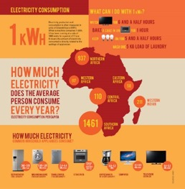 | Infographics will be used to break up larger chunks of text or to outline a series of steps within a process. | 1 day
 | Photographs | Photographs show real world examples of situations or a process. Photographs often enhance a learner’s understanding of a written piece of text. |  | It is envisioned that photographs will be used extensively throughout the course. Photographs are a cost-effective way of demonstrating a series of steps or a simple process. | 0.125 days
 | Charts and graphs | A chart/graph is a visual representation of a set of data. | 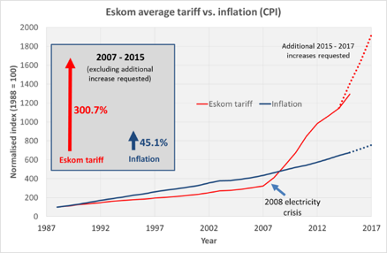 | Similarly, to infographics, charts and graphs will be used to break up information into manageable chunks throughout the course. | 0.5 days
Videos | Animation | An animation is a simulation of movement created by displaying a series of pictures, or frames, often with an explanatory voice over. | 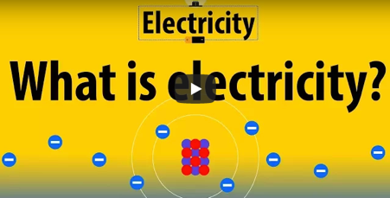 | Animated videos are an effective way to explain scientific concepts such as Atomic Theory which is covered in Course 1: Electrical Principles. They are particularly useful when representing more abstract concepts. | 2 days
 | Documentary | A documentary film is a nonfictional film intended to document some aspect of reality, primarily for the purposes of instruction, education, or maintaining a historic record. | 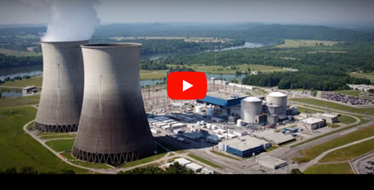 | Course 1: Unit 1 World of Electrician, calls for electricians in the field to be interviewed about their experiences on the job and career opportunities in their field. | 7 days
 | Practical demonstrations | These videos showcase a practical demonstration of a task or process. There is usually someone who is explaining the task which is combined with close-up shots of the task or process as it is physically demonstrated. | 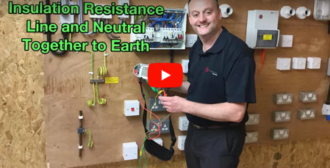 | As the role of an electrician is highly practical we envision that there will be many of these practical demonstration type of videos throughout the course. | 1 day
 | Instructional videos | These videos provide specific instruction on a topic. They often entail the presenter writing/drawing on an electronic board, whiteboard or paper and/or presenting a pre-prepared presentation. | 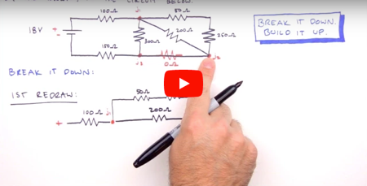 | In Course 1: Electrical Principles and Course 7: Electronics, learners need to be able to solve various problems involving resistors in series and parallel. An instructional video can show them how to do these calculations. | 0.5 days
Simulations |  | A simulation is the imitation (including of feedback systems) of the operation of a real-world process or system. | 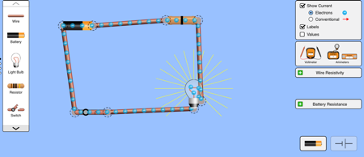  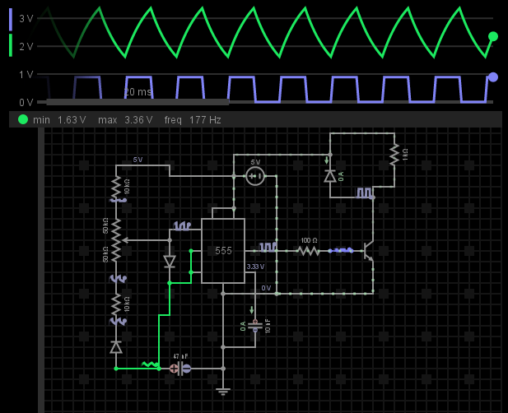 | Simulations are a very effective way of getting a learner to grapple with and understand concepts such as electrical currents Where possible simulations will be sourced from reputable websites such as PHET a programme offered by the University of Boulder Colorado but there may be instances where simulations will need to be created especially for this course. | 10 days
Immersive/  Interactive mini lessons |  | Immersive/interactive mini lessons are collections of materials that have been developed using a content authoring tool. An important feature of these lessons is that learners can actively participate in how they engage with the materials. For example, instead of a normal multiple-choice question, learners may be asked to drag and drop the correct option into a designated area. | 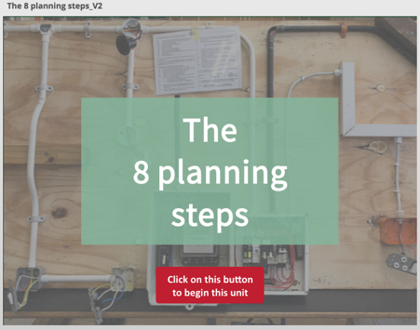 | As the course will be designed with a mobile first approach, great effort is being taken to ensure that text and static information is kept to a minimum. An effective way of ensuring this is by using mini interactive lessons to lift the content and make it more interesting and interactive for the learner. These mini lessons will be used throughout the programme. | 4 days
Audio | MP3 recordings | An audio recording is an electronic recording of sound. Audio recordings can be used to create interesting activities such as a learner being asked to listen to a phone call where a client gives them a brief and they must make a note of the details provided by the client. |  | Audio recordings will be used to create interesting activities such as a learner being asked to listen to a phone call where a client gives them a brief and they must make a note of the details provided by the client. | 0.5 days

Media types
The learning management system hosting the DHET Occupational Certificate: Electrician Programme will be required to accept the following media types:
- JPEG image
- PNG image
- MP4 video
- MP3 audio
- AAC audio
- HTML5 - includes HTML, CSS2 and JavaScript

Estimation of materials required for DHET Occupational Certificate: Electrician Programme.
As the materials for the 11 courses within the programme are still being refined, it is estimated that there will be up to a maximum of 27 digital learning resources required for each one of the 200 units, up to a maximum of 5400 DLRs, with varying complexity from simulation to simple images. It should be noted that each course will require different numbers of DLRs depending on the content and that not all DLRs will be created from scratch some of these will be YouTube videos, Open Educational Resources that already exist for that specific content and stock images. For example, the units within Course 1 may only require 10 DLRs while the units within Course 4 may require 30 DLRs per unit. It should also be noted that some DLRs such as documentary or instructional videos will require more time and effort than other DLRs such as photographs or infographics.

Production prerequisites
For the production process to commence there are three prerequisites that need to be fulfilled. These

- Completed storyboards
Storyboards for all units of the DHET Occupational Certificate: Electrician Programme must be completed in terms of content provided, instructional design application and detailed instructions for the DLRs required.

- Production quality criteria
This document will outline quality and standards required for each type of DLR.

- Style guides
To ensure that there is uniformity in the look and feel for this programme, detailed style guides will be provided to the production company. These style guides will contain guides for the following: logos, fonts, tone of voice, colour palette, image guidelines, video guidelines, writing/editing tips, navigation. NBA has already commissioned a graphic designer to create a colour palette and other graphic design elements such as banners, icons and text boxes to be used as a guide for the Production Company. (See Graphic Design Assets)

- Digital Asset Register
This spreadsheet will outline all the DLRs to be produced for all courses.

Production process
To expedite the production of DLRs it is envisioned that the following activities will be cyclical. Each course will follow the activities listed below. Depending on the size and capacity of the production company this means that the DLRs for courses can be developed in parallel to other courses, it does not have to be sequential. Here is a suggested list of activities within the production process, along with estimated level of effort required and proposed timelines.

# | Activity | Responsibility | Estimated Timeframe per course
1 | Write detailed production briefs for each of DLRs | NBA | 1 - 2 months
2 | Subject Matter Expert to review production brief and provide correction/input on production briefs | SMEs
3 | Produce first drafts of DLR | Production Company | 3 – 6 months
4 | Review drafts considering the following; adherence to production quality standards, adherence to production brief and accuracy of content. SME’s will be requested to provide input on a sampling of DLRs  * This is an iterative process and will be repeated until a satisfactory product has been produced | NBA
 |  | SMEs
5 | Produce final version of DLRs | Production Company
6 | Upload onto LMS | DHET/ Production Company | 3 months
7 | Final quality assurance | NBA
 |  | DHET
 |  | SMEs
8 | Usability test on a programme component (one course will be used for this purpose)  * Is it recommended that the usability testing be conducted on completion of a single 0course to ensure that changes and lessons learnt are incorporated in the development of other DLRs | NBA | 1 month
 |  | DHET
9 | Implement changes to the LMS informed by the usability test | NBA
10 | Summative Evaluation | NBA | 4 – 6 months
 |  | DHET

Notes on time allocation :
- As the number of resources required per course and the complexity of these resources will differ quite markedly, it is not possible to give a precise estimate per course. What is provided is an estimate of the average time required for each step.

Risk Assessment and suggested solutions
As can be seen by the estimation of materials required DHET Occupational Certificate: Electrician Programme, there are many DLRs that need to be produced. With such a large-scale production of DLRs there some risks that have been identified and need to be mitigated before and during the production phase.

Size of assets
As this programme is being developed primarily for mobile use, it is important that all assets such as the videos and interactive packages are not too big as this will make the data costs for accessing this programme unfeasible. Specifications for each type of DLR will be outlined in the Production Quality Criteria document which will be provided to the Production Company at the beginning of the process.

Quality of assets
It is quite possible that due to the number of assets that need to be produced that there will be many stakeholders involved in the project. NBA will be the central organising stakeholder that will clearly communicate the expected quality of materials up front (by means of the Production Quality Criteria document and style guides) and then monitor that those standards are upheld throughout the process.

Lack of Subject Matter Expert (SMEs) involvement
As the information within this programme is highly specialised and highly technical it is important that SMEs are intimately involved in the production process from advising the content that should go into the scripts for videos, making their facilities available for filming, revising the drafts of assets and signing off the final products to be loaded onto the learning management system. Without access to SMEs that are prepared to be committed, engaged and available the process of producing assets will be time consuming, laborious and unnecessarily expensive. NBA will require the assistance of DHET in to provide an advisory role in terms of suggestions of the best SMEs to approach for this phase of development.

Time and cost overruns
The production of videos, interactive packages and animated videos can be very costly. NBA will work closely with the Production Company to ensure that there are regular updates in terms of the process achieved in producing the DLRs and the costs associated with producing the DLRs. This is important to ensure that the Production Company does not sacrifice quality to make up for time and cost overruns.

https://en.wikipedia.org/wiki/Digital_learning
https://www.ucc.ie/en/teachlearn/resources/udl/materials/
Each of these resource types exists along a wide range of complexities and therefore it is not possible to give a precise production time estimate. What is provided is an estimate of the time required to produce a resource at the mid-range of this complexity spectrum.
https://www.smartdraw.com/diagrams/
https://en.wikipedia.org/wiki/Documentary_film
https://phet.colorado.edu/en/simulations/category/new

